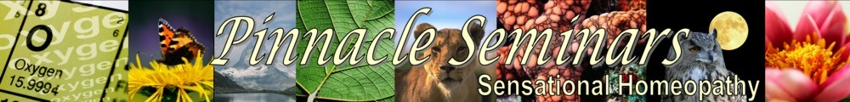
‘Peter wants his descriptions to be perfect and his provings to go to the depth and core of the remedy’, Jan Scholten
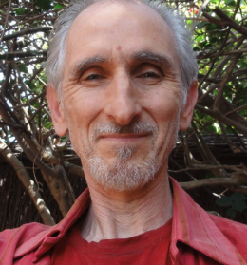
Peter Tumminello
20-22 May 2016

The Kairos Centre
Roehampton
London SW15 4JA

The Gems Within
The Essence of the Essence
Throughout the ages, Gemstones have been associated not only with beauty and wealth but also attributed healing properties, subtle powers and sacred connections. To bring out the true essence of these rare and noble products of nature required someone able to connect and hold that sensitive space in which the whole picture could manifest.
Australian homeopath and gemmologist Peter Tumminello is certainly that person: Someone with a lifelong connection to and respect for gems and nature which led him on a meticulous exploration, using a variety of proving means, both conventional and meditative. The outcome has been remedy pictures, grounded in the common physical and psychological aspects, largely in Rows 1 to 3 of the Periodic Table, but which also bring out a higher spiritual meaning giving wholeness to our understanding of these remedies and the patient’s path. Peter’s deep respect for the gems and their integral nature did not allow him to break them in order to triturate. Instead, they were immersed in water and then potentised.
Remedies of our Age
Gemstones begin life as common rocks which are then forged by the earth’s powerful forces, remarkably transforming them into radiant and colourful stones that stand apart from more common substances. The earth however does not easily give up this bounty.
The picture is of a struggle between the lower and higher aspects of being, the forging of consciousness, the will to break free out of darkness into light and to truly manifest, a journey of transformation and transcendence.
The seminar will be an opportunity not only to hear about those remedies contained in Peter’s current books The Twelve Jewels, and Rose Quartz, but a new work scheduled to be published later in 2016.
For practical information go to www.pinnacleseminars.co.uk

___________________________________________________________________________________________________

Peter Tumminello – Kairos Centre, Roehampton 20-22 May 2016*

Payment by cheque – please tick as appropriate

Fee (early bird: pay by 1.4.16); and students…………………………………… £240 ………………. .

Fee after 1.4.16: …………………………………………. £265………………. .

Day rate: Please indicate which day (Fri, Sat, Sun)…………………………….. £ 90 (per day)..…… .

Cheques made payable to Pinnacle Seminars and posted to 99 Cottenham Park Road, London, SW20 0DS
If you wish to pay by paypal (2 ½% surcharge), go to www.pinnacleseminars.co.uk) For payment by bank transfer
please email info@pinnacleseminars.co.uk for details

I wish to attend the above seminar and enclose my cheque(s) for _____________________

Name ________________________________________ Email ________________________________________

Address ______________________________________________________________________________________

Date ________________________________________ Telephone _____________________________________

* Some low cost accommodation is available at the Kairos Centre. Please contact them direct to book. (020) 8788 4188

